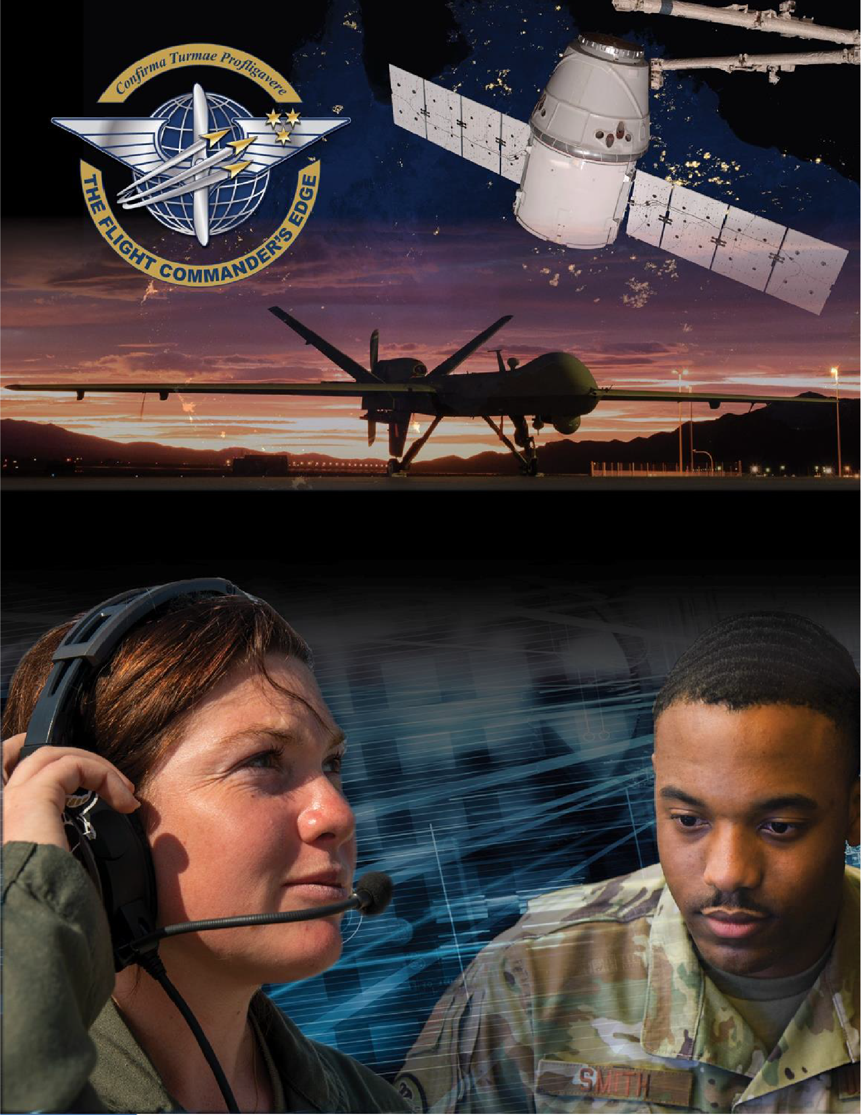

Lesson Guide

Prioritization

***14 April 2025***

# Prioritization

**Purpose**

This lesson guide is designed to support the local development of Flight Commander Leadership Course materials. Selected facilitators should use this guide as they prepare presentation materials. For more information on how lessons are structured, or how to use them in the course, see the ***Course Director’s Handbook*** or online Facilitator Resources.

# Scope

Prioritization is a major factor in even a single day’s success within the Department of the Air Force. There will always be certain tasks which must be completed immediately and other tasks which can simply wait; knowing the difference can be challenging, especially when someone of higher rank (typically outside of the organization) stresses the importance of their task.

As a Flight Commander, you may have to adapt your personal methods of prioritizing to successfully lead your flight. It is critical to align your efforts with the Squadron (or equivalent) Commander’s priorities. You must also orchestrate this alignment across your team and ensure your flight leadership maintains consistent messaging regarding prioritization. Prioritizing should always be informed by the demands of the mission along with considerations such as manning suspenses (performance report closeouts, awards, decorations, etc.). Amidst all this, every individual must maintain some level of personal time to avoid burn-out.

# Recommended Objectives

By the end of this lesson, the participant should be able to:

1. Understand the need for prioritization and the distinctions between prioritizing individually versus prioritizing as a flight leader.
2. Understand what factors will drive your prioritization as a flight leader.
3. Recognize how to handle issues (short-notice taskers, manning emergencies, disciplinary actions, safety concerns, etc.) which might complicate a flight leader’s routine priorities.

# Recommended POC / Presenter

* Squadron-level leader (DO, CC or equivalent)

# Recommended Length:

* 30 minutes (inclusive of questions)

# Recommended Approach

* Present informational slides with Q & A

# Lesson Connections

* **Conflict Management-**Priorities which are in tension can cause conflict and a Flight Commander must manage this.
* **Time and Meeting Management-**Most prioritized efforts require time, a finite resource. Flight Commanders must manage their time and their team’s time (including meetings) to meet priorities optimally.
* **Organizational Structure and the Mission-**A unit’s mission will lend high priority to certain efforts and tasks. Furthermore, a Flight Commander must field important tasks from both internal and external sources which will drive prioritization.
* **New Problems, New Thinking-**As a Flight Commander, your new scope of responsibility may require adaptation of your personal prioritization methods to successfully lead your flight and optimize mission accomplishment.